1. Using postman without sending api key

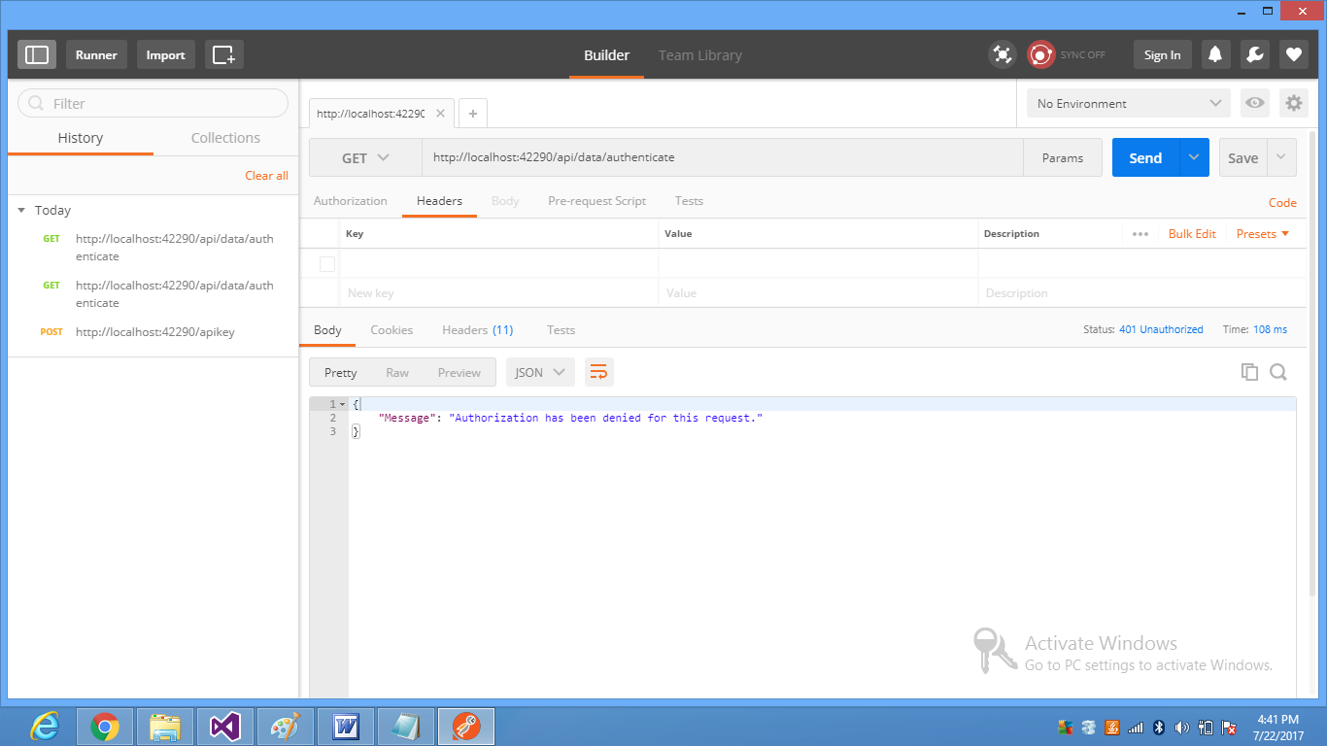

2. Generate api key passing grant_type, username and password in body using POST method

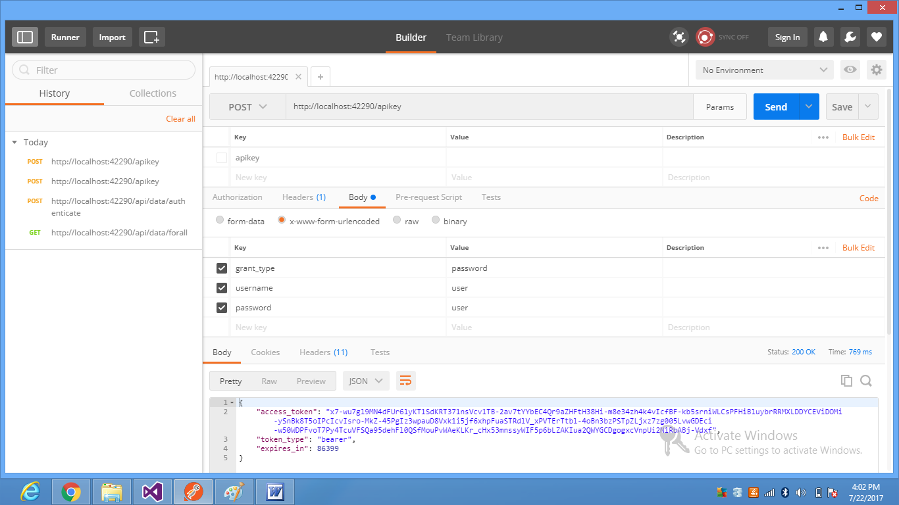

3. Sending Authorization key value in header

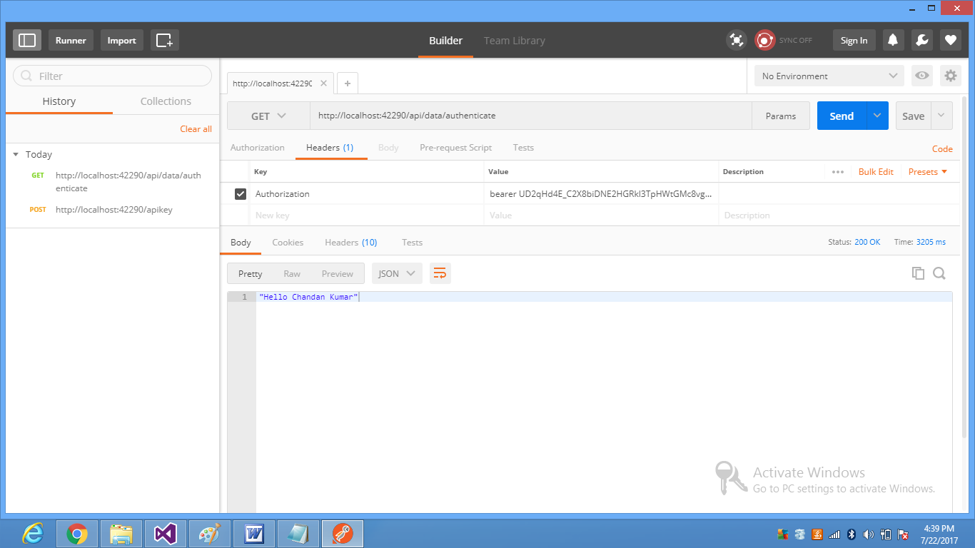

4. Getting data from the server only for hr role type user.
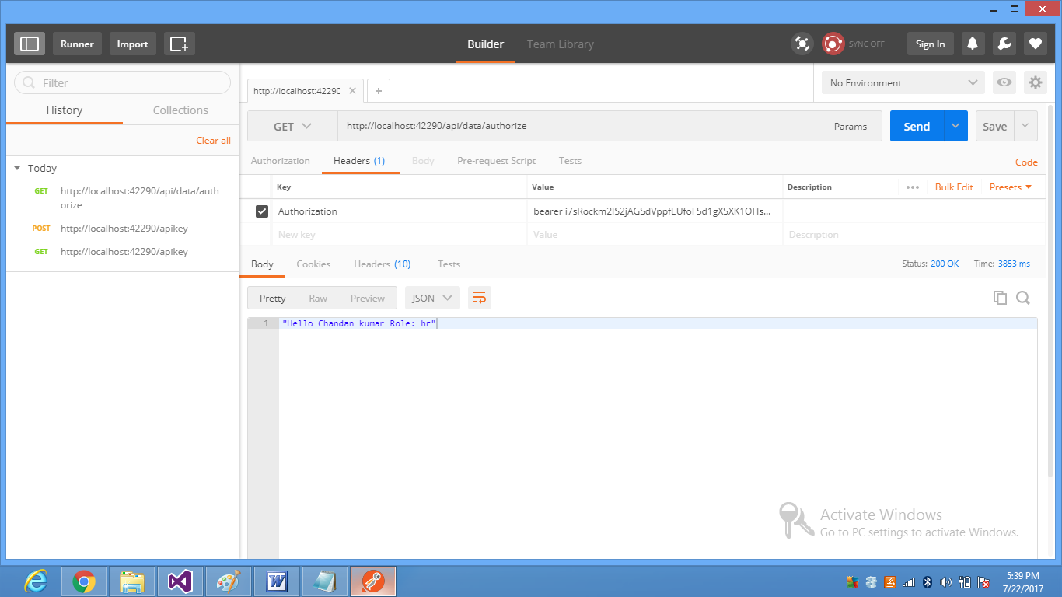

Pass Roles to authorize attribute
[Authorize(Roles = "hr")]

Also add role to identity claim
identity.AddClaim(new Claim(ClaimTypes.Role, "hr"));

